* **Vraj Patel.**
* **Software Testing Assignment.**

**1.What is SDLC?**

* SDLC is a structure imposed on the development of a software product that defines the process for planning, implementation, testing, documentation, deployment, and ongoing maintenance and support.

**2.What is software testing?**

* Software Testing is a process used to identify the correctness, completeness, and quality of developed computer software.

**3. What is agile methodology?**

* The Agile methodology is a way to manage a project by breaking it up into several phases. It involves constant collaboration with stakeholders and continuous improvement at every stage. Once the work begins, teams' cycle through a process of planning, executing, and evaluating.

**4. What is SRS?**

* A software requirements specification is a complete description of the behavior of the system to be developed. It includes a set of use cases that describe all of the interactions that the users will have with the software. Use cases are also known as functional requirements. In addition to use cases, the SRS also contains nonfunctional requirements.

**5. What is oops?**

* Ops is also known as Object Oriented Programming.
* Programming is like writing. If you can write a demonstration, you can make a program.

**6. Write Basic Concepts of oops?**

* Identifying objects and assigning responsibilities to these objects.
* Objects communicate to other objects by sending messages.

**7. What is object?**

* Everything in the world is an object.
* A flower, a tree, an animal A student, a professor A desk, a chair, a classroom, a building A university, a city, a country the world, the universe A subject such as CS, IS, Math, History, …

**8. What is class?**

* Class is a blue print for an object.
* Class means abstraction of the object and abstracts the properties and behavior of that object.

**9. What is encapsulation?**

* Encapsulation is the practice of including in an object everything it needs hidden from other objects. The internal state is usually not accessible by other objects.

**10. What is inheritance?**

* Inheritance means that one class inherits the characteristics of another class. This is also called a “is a” relationship.

**11. What is polymorphism?**

* Polymorphism means “having many forms”. It allows different objects to respond to the same message in different ways, the response specific to the type of the object.

**12. Write SDLC phases with basic** introduction.

* (1) Requirements Collection/Gathering: This is the first stage of SDLC phase. It includes establish customer needs.
* (2) Analysis: This is second stage of SDLC phase. The analysis phase defines the requirements of the system, independent of how these requirements will be accomplished. This phase defines the problem that the customer is trying to solve.
* (3) Design: Design Architecture, Document Implementation, Plan Critical Priority Analysis, Performance Analysis, Test Plan... etc. are includes in Desing phase for SDLC.
* (4) Implementation: In the implementation phase, the team builds the components either from scratch or by composition. Given the architecture document from the design phase and the requirement document from the analysis phase, the team should build exactly what has been requested, though there is still room for innovation and flexibility.
* (5) Testing: Software Testing is a process used to identify the correctness, completeness, and quality of developed computer software.
* (6) Maintenance: Software maintenance is one of the activities in software engineering, and is the process of enhancing and optimizing deployed software as well as fixing defects.

**13. Explain Phases of the waterfall** model.

* (1) Requirements Collection/Gathering: This is the first stage of SDLC phase. It includes establish customer needs.
* (2) Analysis: This is second stage of SDLC phase. The analysis phase defines the requirements of the system, independent of how these requirements will be accomplished. This phase defines the problem that the customer is trying to solve.
* (3) Design: Design Architecture, Document Implementation, Plan Critical Priority Analysis, Performance Analysis, Test Plan... etc. are includes in Desing phase for SDLC.
* (4) Implementation: In the implementation phase, the team builds the components either from scratch or by composition. Given the architecture document from the design phase and the requirement document from the analysis phase, the team should build exactly what has been requested, though there is still room for innovation and flexibility.
* (5) Testing: Software Testing is a process used to identify the correctness, completeness, and quality of developed computer software.
* (6) Maintenance: Software maintenance is one of the activities in software engineering, and is the process of enhancing and optimizing deployed software as well as fixing defects.

**14. Write phases of spiral model.**

* (1) Planning: This phase includes requirement gathering and analysis. Based on the requirements, objectives are defined and different alternate solutions are proposed.
* (2) Risk Analysis: In this quadrant, all the proposed solutions are analyzed and any potential risk is identified, analyzed, and resolved.
* (3) Customer Evaluation: Assessment of the result of engineering.
* (4) Engineering: Development of the “next level" product.

**15. Explain working methodology of** agile model and also write pros and cons.

* Meaning: Agile SDLC model is a combination of iterative and incremental process models with focus on process adaptability and customer satisfaction by rapid delivery of working software product. Agile Methods break the product into small incremental builds.
* Agile model believes that every project needs to be handled differently and the existing methods need to be tailored to best suit the project requirements. In agile the tasks are divided to time boxes to deliver specific features for a release.
* Pros: Is a very realistic approach to software development Promotes teamwork and cross training.
* Functionality can be developed rapidly and demonstrated.
* Resource requirements are minimum.
* Suitable for fixed or changing requirements Delivers early partial working solutions.
* Good model for environments that change steadily.
* Minimal rules, documentation easily employed.
* Enables concurrent development and delivery within an overall planned context.
* Little or no planning required Easy to manage Gives flexibility to developers.
* Cons: Not suitable for handling complex dependencies.
* More risk of sustainability, maintainability and extensibility.
* An overall plan, an agile leader and agile PM practice is a must without which it will not work.
* Strict delivery management dictates the scope, functionality to be delivered, and adjustments to meet the deadlines.
* Depends heavily on customer interaction, so if customer is not clear, team can be driven in the wrong direction.
* There is very high individual dependency, since there is minimum documentation Transfer of technology to new team members may be quite challenging due to lack of documentation.

**16. Draw Use case on Online book shopping.**

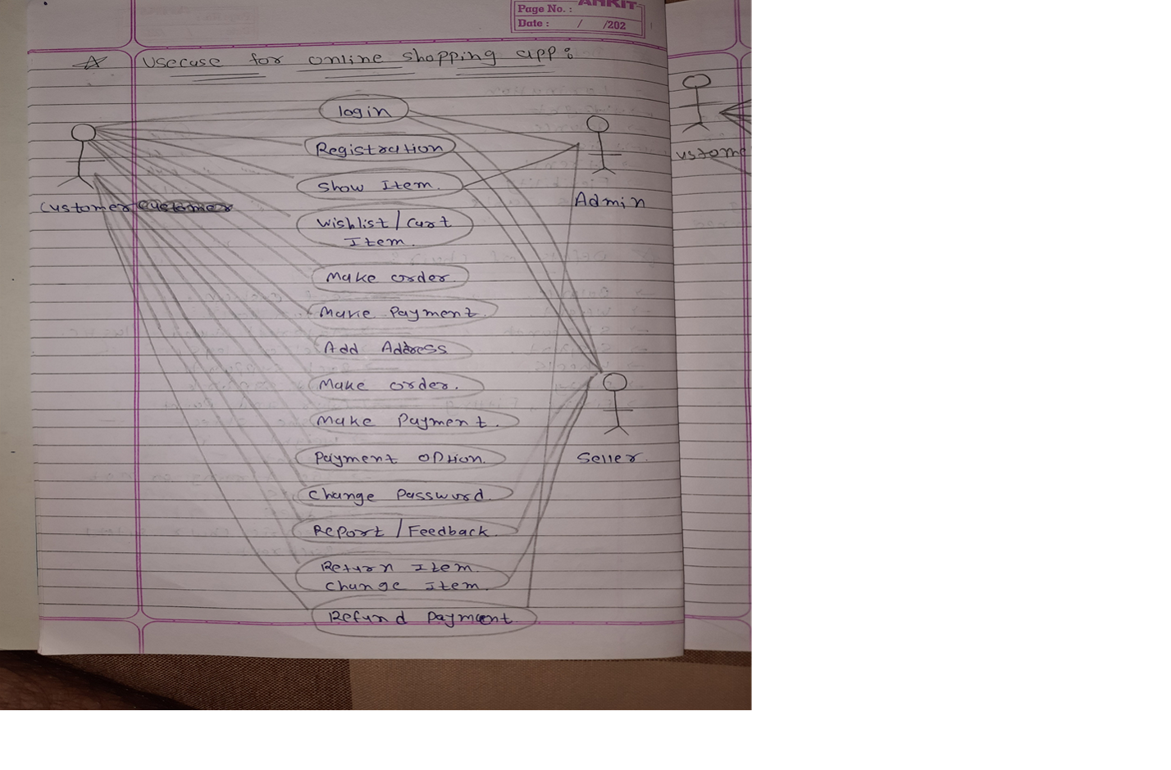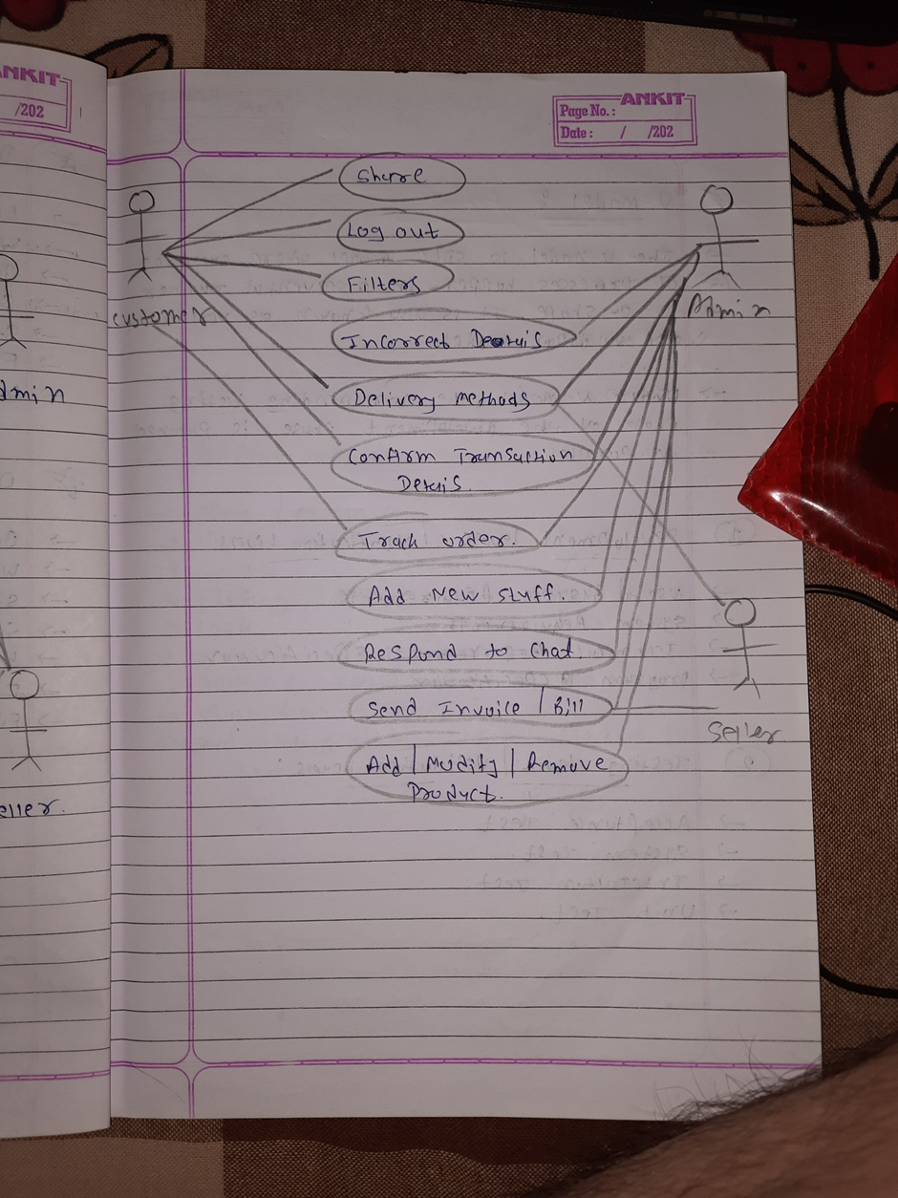

**17. Draw Use case on online bill payment system (Paytm).**

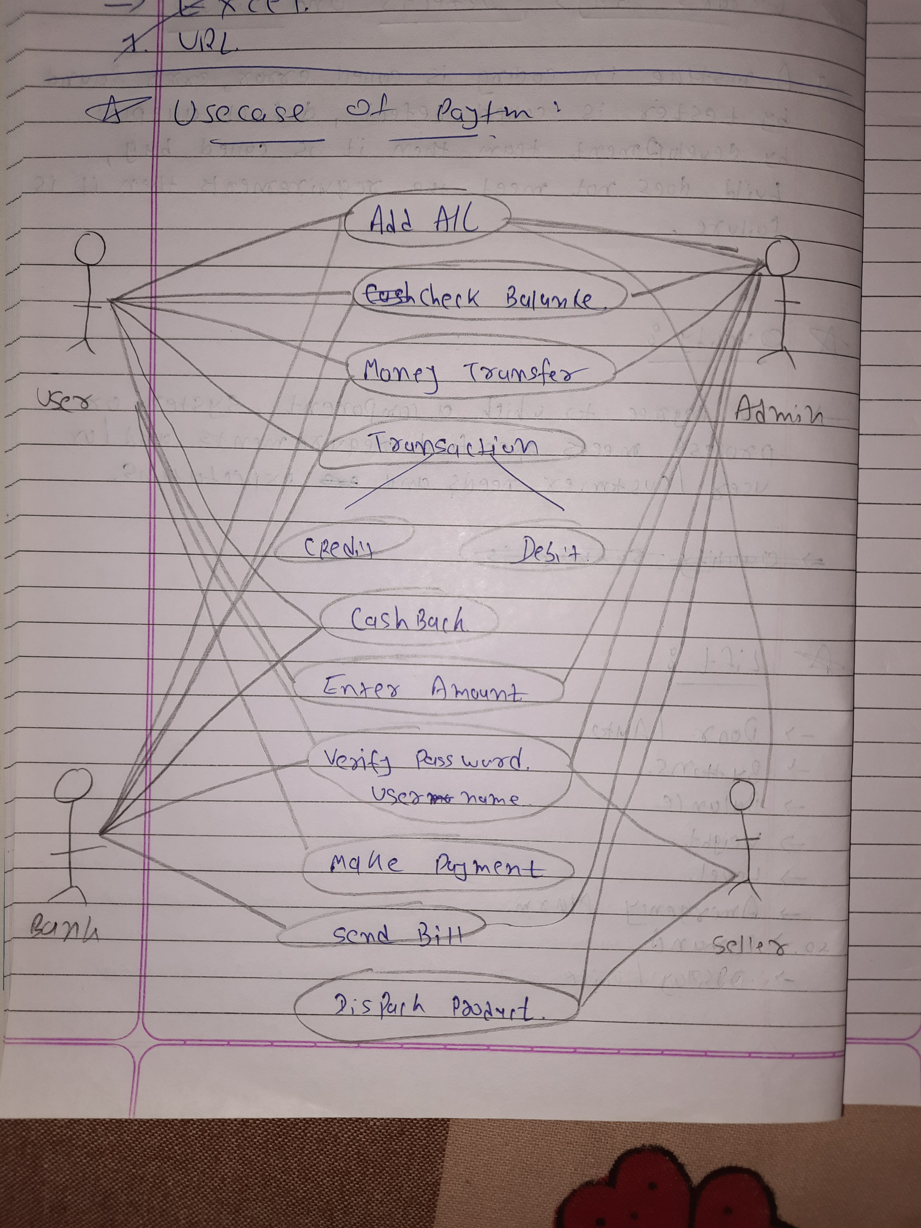

**18.** **Draw use case on Online shopping product using COD.**